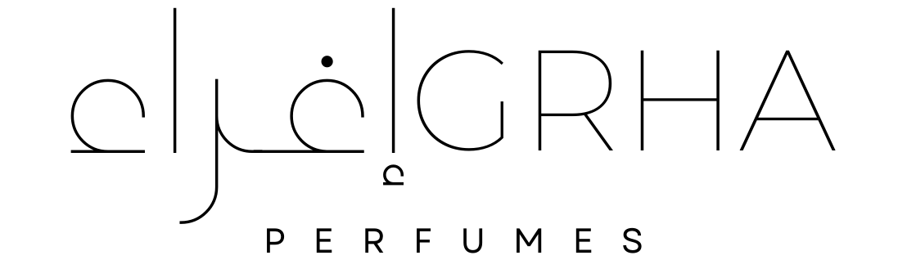

Ighra Perfumes Refund & Exchanges Form
This form is to be completed and then sent to the Ighra Perfumes team by email: support@ighraperfumes.com for any refund and exchange claims
Policy Summary:
We can only process a refund/exchange within 14 days of receiving the product back in good, unused and undamaged condition in its original and undamaged packaging.
We are unable to re-imburse or pay you the cost incurred for sending the product back to us
If it turns out we have made the mistake with your order then the cost you incur when sending us back the product will be re-imbursed
Upon receipt of the product, we will
- Inform you it has been received
- Complete our checks to ensure it meets the requirements for your refund and exchange
- If all is fine, we will process what you have requested
3.1 Refunds: We will inform you that this has been processed. It can take up to 5 working days for this to reach your bank | 3.2 Exchanges: Will inform you this has been processed. We will use the same shipping method you paid to ship out your exchanged item.
- If there are any issues, we will communicate this to you.
- For further details about our Refund & Exchange Policy, please click here

Please ensure all the information you enter is correct on this form.
Full Name |  |  |  | Email address
XXX XXXX |  |  |  | XX@XX.com
Order Number |  |  |  | Date of Purchase
XXXX XXXXX |  |  |  | XX/XX/XXXX
Product Name: |  | XXXX
Product Description: |  | XXXX
Colour: |  | XXXX
Amount: |  | XXXX
Price: |  | XXXX
I am requesting a: (please tick what is applicable)
Refund |  |  | Exchange
Please select the reason:
Product is Damaged |  | The wrong item was sent |  | Item ordered does not match the description | Ordered the wrong product
Other | Please provide reason:  ____XXXX__________________________________________________
Please provide details of the product you want to exchange with:
Product Name: |  | XXXX
Product Description: |  | XXXX
Colour: |  | XXXX
Amount: |  | XXXX
Price: |  | XXXX

Electronic Signature:
Date:

